Polymorphism:

When the same function behaves differently in different scenarios, it is known as Polymorphism.

There are two types of polymorphism:

1. Compile Time Polymorphism

A function is called at the time of program compilation. Function overloading and operator overloading is the type of Compile time polymorphism.

I. Function Overloading:
Function overloading means one function can perform many tasks with the same name and different types of arguments.

Example:

#include <iostream>
using namespace std;
class Addition {
public:
int ADD(int X,int Y) // Function with parameter
{
return X+Y; // this function is performing addition of two Integer value
}
int ADD() { // Function with same name but without parameter
string a= "HELLO";
string b="SAM"; // in this function concatenation is performed
string c= a+b;
cout<<c<<endl;

}
};
int main(void) {
Addition obj; // Object is created
cout<<obj.ADD(128, 15)<<endl; //first method is called
obj.ADD(); // second method is called
return 0;
}

OUTPUT:

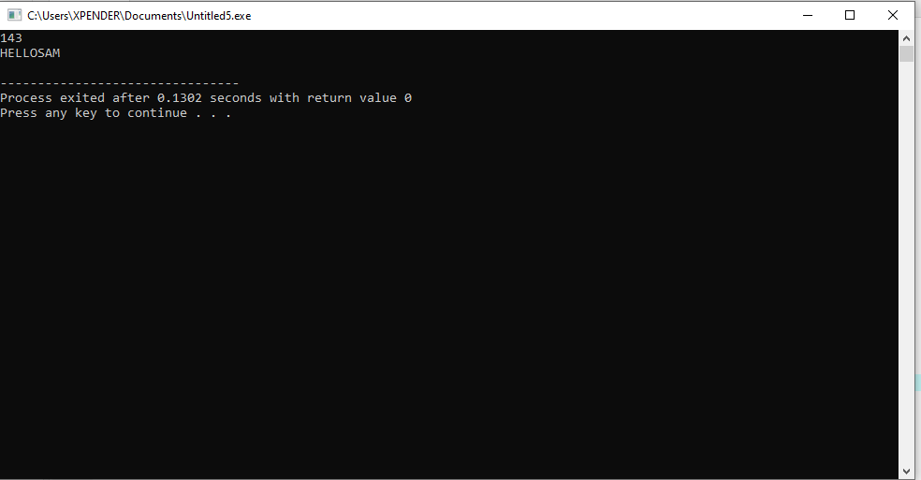

II. Operator Overloading
The of Operators overloading is to perform different operations on the same operand.

EXAMPLE:
#include <iostream>
using namespace std;
class A
{

string x;
public:
A(){}
A(string i)
{
x=i;
}
void operator+(A);
void display();
};

void A:: operator+(A a)
{

string m = x+a.x;
cout<<"The result of the addition of two objects is : "<<m;

}
int main()
{
A a1("Welcome");
A a2("back");
a1+a2;
return 0;
}

OUTPUT:
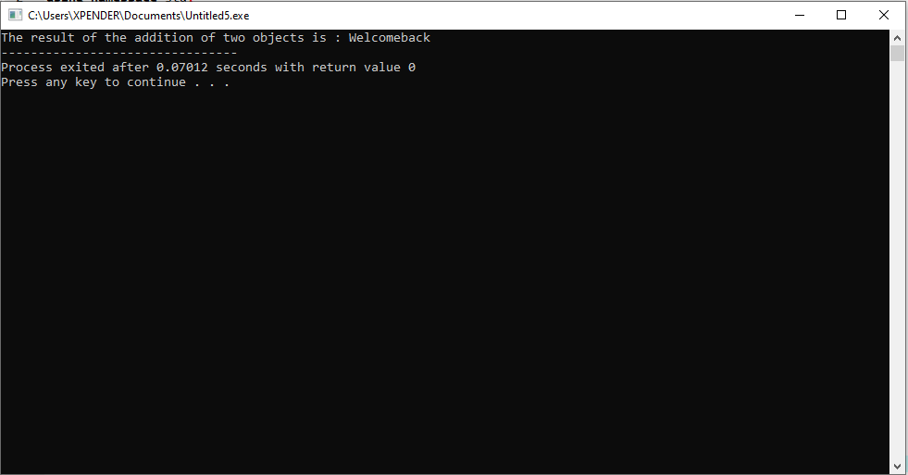

2. Runtime Polymorphism
Runtime polymorphism, functions are called at the time the program execution. Function overriding is a part of runtime polymorphism. It is achieved by using virtual functions and pointers. It provides slow execution as it is known at the run time. Thus, It is more flexible as all the things executed at the run time.

I. Function overriding
In function overriding, we give the new definition to base class function in the derived class. At that time, we can say the base function has been overridden. It can be only possible in the ‘derived class’. In function overriding, we have two definitions of the same function, one in the superclass and one in the derived class. The decision about which function definition requires calling happens at runtime. That is the reason we call it ‘Runtime polymorphism’.

